CMR Institute of Technology

**Kandlakoya Village, Medchal Rd, Hyderabad, Telangana 501401**

**Institute Innovation cell**

**Developing Online Repository of Ideas Developed and Wayforward plan**

**Team Name: BEST OF BEST**

Members:

1.B.Sai chandana 20R01A0464

2.Gudikandla.Tejasri 20R01A0472

3.Kalva.Sabitha 20R01A0479

4.Kaitha.Pavani 20R01A0482

5.Kuchipudi.Bhavani 20R01A0486

Idea Title:SMART STREET LIGHTS

Problem Statement:To save electricity in street lights

# OVERVIEW

Our project for developing a smart street light system.The smart street lights provides a solution for power saving which is achieved by sensing an approaching vehicle using the IR sensors and then switching ON a block of street lights,as vehicle passes lights switch OFF automatically.

# GOALS/Objectives

1.To reduce power consumption when there are no vehicle movements on the road.

2.Reducing physical efforts

3.Improve the system in our daily life

# SPECIFICATIONS

Smart street lights more efficiency manage electricity,leading to greater cost savings compared to simple LED luminaries.Increasad revenue oppurtunities.

# MILESTONES

## Ideation/Data collection

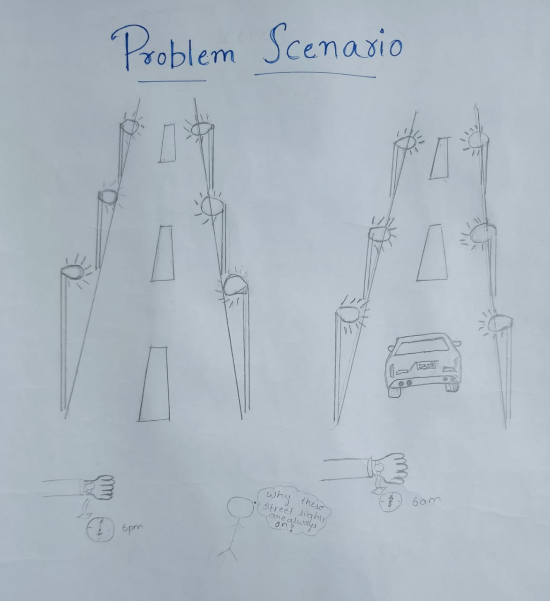

Fig 1: Problem scenario

## Model Building

Connect all the components as shown in the circuit diagram.Connect all IR sensor’s to +5v and ground.The positive pin of leds are connected to these pins of arduino,and finally all ground pins of led connect to the ground of arduino.To make these poles as as given in above picture ,use foam board and glue.

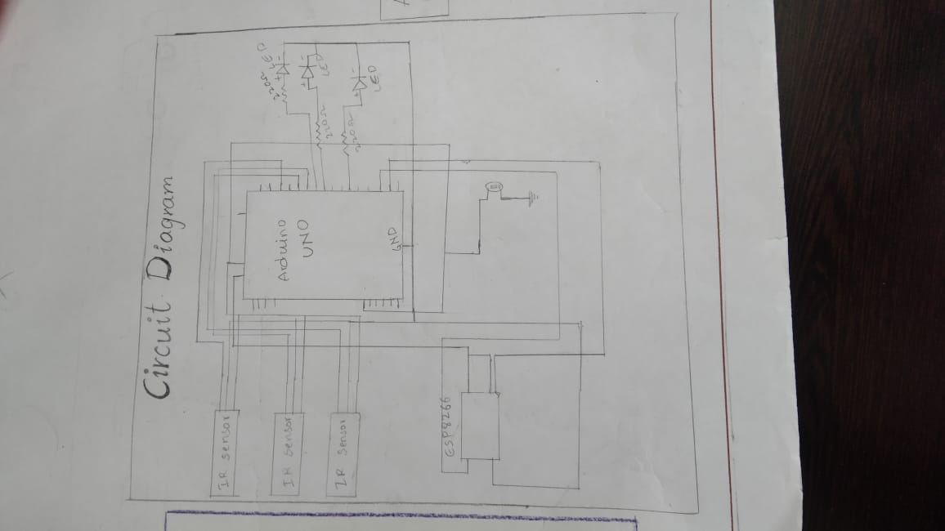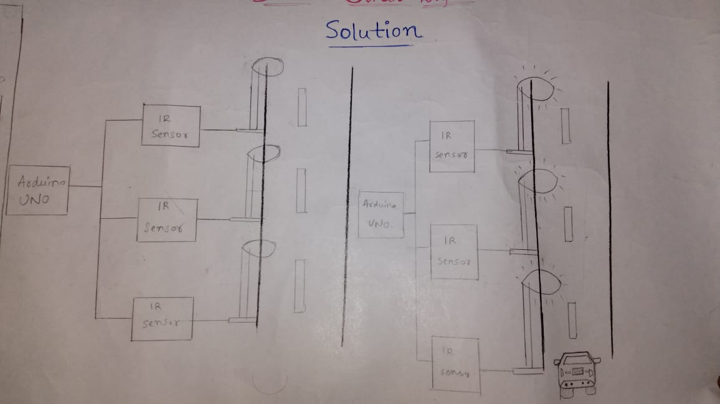

Fig 2:model or blueprint

## Components/Tools Understanding and usage

ARDUINO UNO

IR sensor

LDR sensor

Connecting wires

Bread board

LEDS

1.The Arduino uno is a open source microcontroller board .The board is equipped with set of digital and analog input/output (I/O)pins.The board has 14 digital I/O pins and is programmable with the arduino IDE ,through it can accept voltages between 7 and 20 volts.

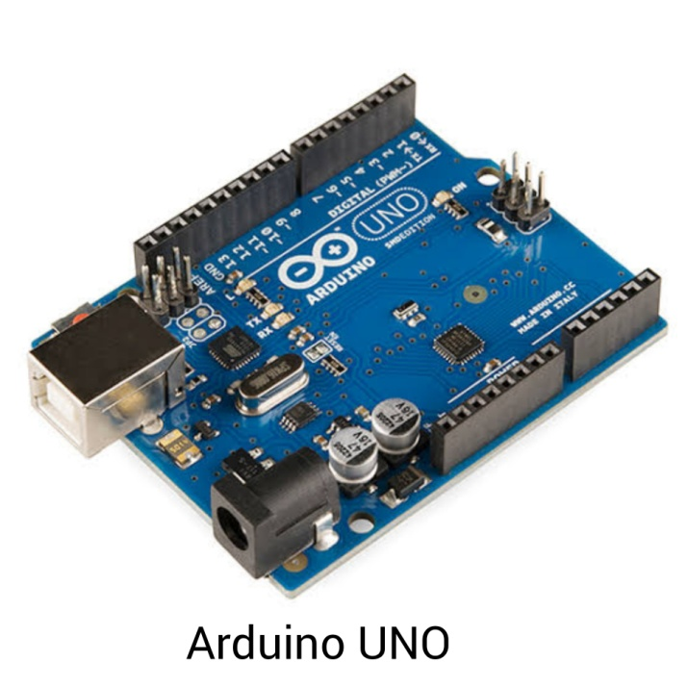

Fig 3.1: Arduino UNO

2.An infrared (IR) sensor is an electronic device that measures and detects infrared radiation in surrounding environment .IR is invisible to the human eye,as its wavelenght is longer than that of visible light,they do not detect any output high(5v).

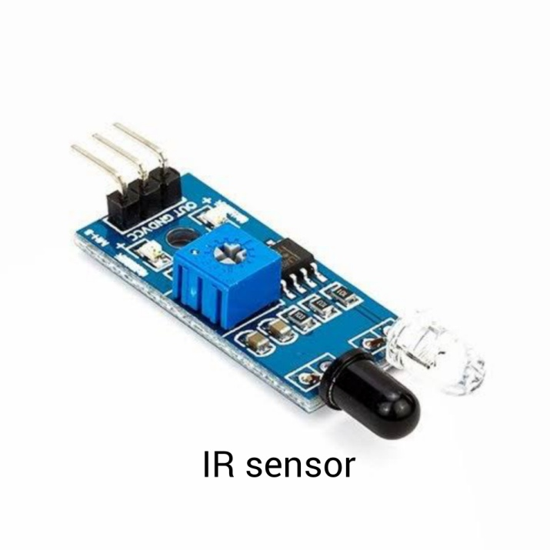

Fig 3.2:IR SENSOR

3.LED-light emitting diode is a semiconductor light source that emits light when current flow through it.

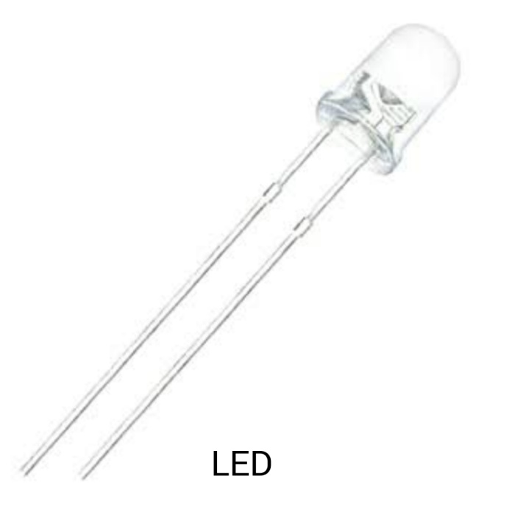

Fig 3.3:LED

4.LDR-A Light Dependent Resistor(LDR) is also called a photoresistor .Street lights are designed to switch on automatically when it is dark and switch off when there is light so as to save energy.That changes according to the amount of light falling on it.

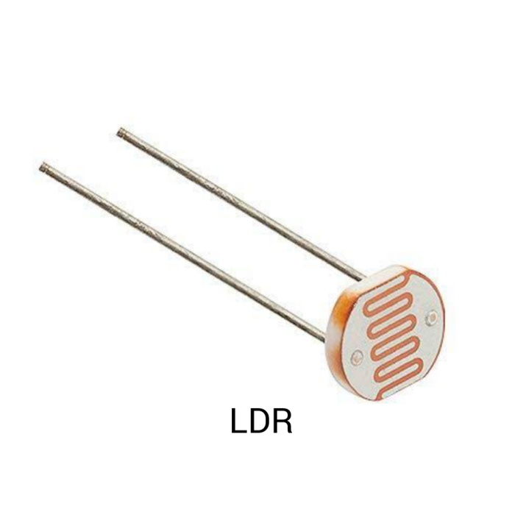

Fig 3.4:LDR SENSOR

5.Resistor:passive two terminal electrical component involve detecting the presence of light

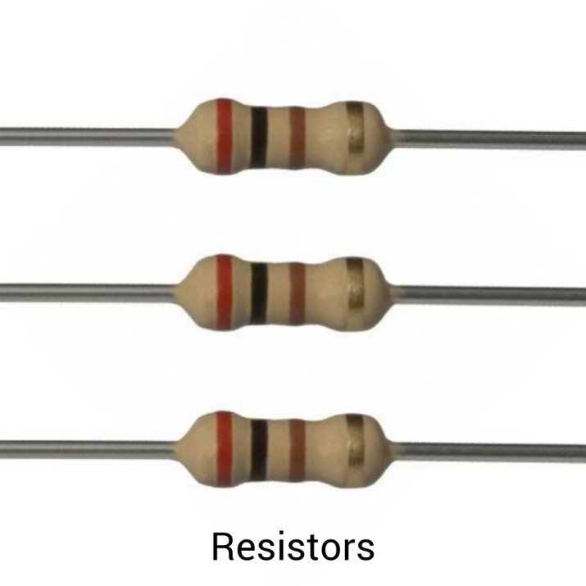

Fig:3.5:resistor

6.connecting wires:wires used to extend the firing line or leg wires in an electric blasting circuit.

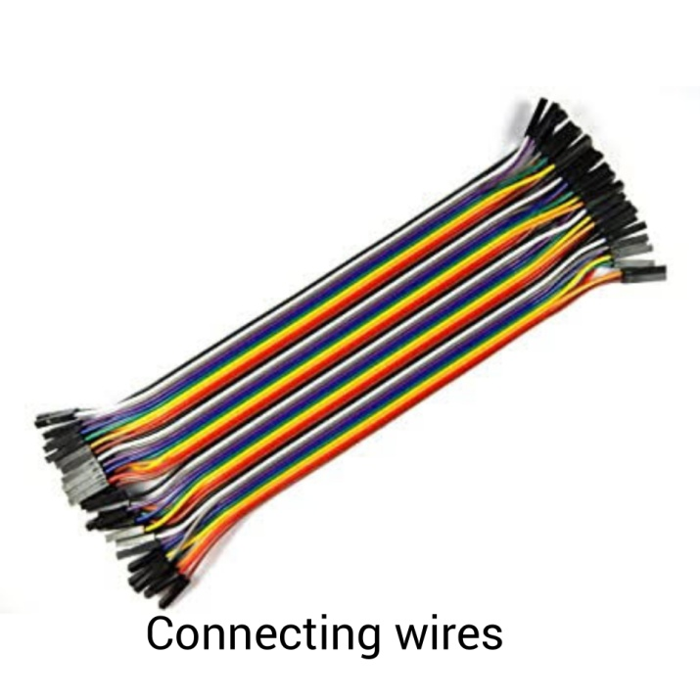

Fig:3.6: connecting wires

7.Breadboard:It is construction base for prototyping of electronics .

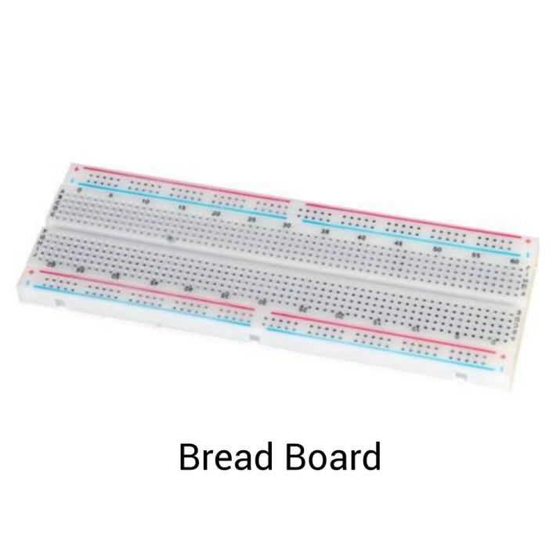

Fig:3.7:Breadboard